**AWS WITH PYTHON | PART 1 : S3 BUCKETS**

1. **List all the AWS buckets in your account**

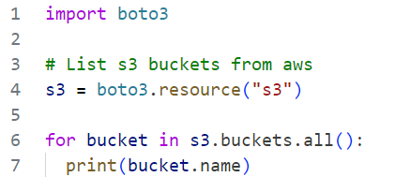

1. **Code Breakdown**

**import boto3:** This line imports the boto3 library, which is the AWS SDK for Python. It enables your Python code to create, configure, and manage AWS services.

**s3 = boto3.resource("s3"):** This line creates a resource service object for S3 using the boto3.resource method. The "s3" argument specifies that the resource to be used is Amazon S3. A resource service object provides a higher-level, object-oriented API, which is typically easier to use compared to the client interface.

**for bucket in s3.buckets.all():**: This line iterates over all the S3 buckets in your AWS account. The s3.buckets.all() method returns an iterable collection of all the buckets that you have access to.

**print(bucket.name):** This line prints the name of each bucket in the iterable collection. The bucket variable represents each individual bucket resource in the collection, and bucket.name accesses the name attribute of the bucket.

1. **Summary**

The entire script essentially performs the following actions:

1. Imports the boto3 library to work with AWS services.
2. Creates an S3 resource object, which allows you to interact with Amazon S3 using a higher-level API.
3. Retrieves a list of all S3 buckets in your AWS account using the s3.buckets.all() method.
4. Iterates through each bucket and prints its name.
5. **Prerequisites**

To run this code successfully, you need to ensure:

* **AWS Credentials:** You have valid AWS credentials configured on your machine. This can be done through environment variables, configuration files, or the AWS CLI.
* **Permissions:** Your AWS credentials have the necessary permissions to list S3 buckets in the account.

1. **Potential Issues**

* **No Credentials Error:** If you don’t have AWS credentials configured, you may encounter a NoCredentialsError.
* **Permission Error:** If your credentials don’t have the right permissions, you might get a ClientError stating that you are unauthorized to list the buckets.

1. **Create a Bucket**

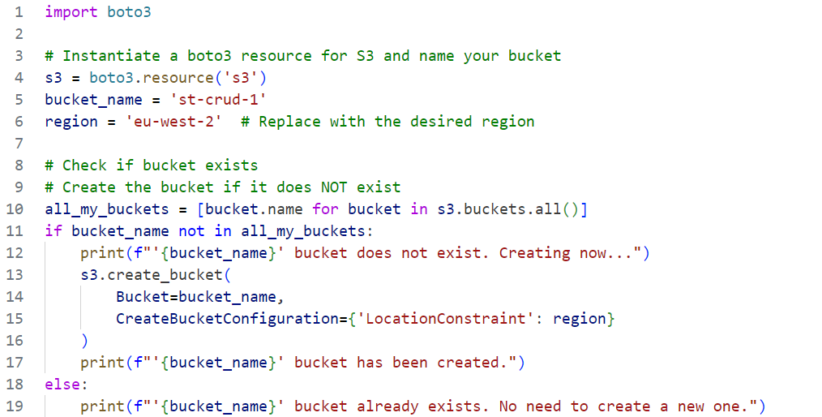

1. **Code Breakdown**

**import boto3:** This line imports the boto3 library, which is the AWS SDK for Python, enabling interaction with various AWS services.

**s3 = boto3.resource('s3'):** This line creates a resource object for Amazon S3. The resource object provides a higher-level, object-oriented API for interacting with S3.

**bucket_name = 'st-crud-1':** This line sets the name of the S3 bucket you want to check or create.

**region = 'eu-west-2':** This line specifies the AWS region where the bucket should be created if it doesn't exist. You can replace 'eu-west-2' with the desired region of your choice.

**all_my_buckets = [bucket.name for bucket in s3.buckets.all()]:** This line retrieves a list of all the S3 buckets in your AWS account and extracts their names into a list called all_my_buckets.

**if bucket_name not in all_my_buckets:** This line checks if the bucket with the name bucket_name exists in the all_my_buckets list.

**print(f"'{bucket_name}' bucket does not exist. Creating now..."):** If the bucket does not exist, it prints a message indicating that the bucket is being created.

**s3.create_bucket(...):** This line creates a new S3 bucket with the specified name and region. The CreateBucketConfiguration parameter is used to set the LocationConstraint to the desired AWS region, ensuring that the bucket is created in the correct geographic location.

**print(f"'{bucket_name}' bucket has been created."):** After the bucket is created, this line prints a confirmation message.

**else:** If the bucket already exists, the script proceeds to the else block.

**print(f"'{bucket_name}' bucket already exists. No need to create a new one."):** This line prints a message indicating that the bucket already exists and no new bucket needs to be created.

1. **Summary**

This script performs the following actions:

1. **Imports the boto3 library** to enable AWS service interaction.
2. **Creates an S3 resource object** to work with Amazon S3.
3. **Sets the bucket name and region** for the bucket to check or create.
4. **Retrieves and checks all existing bucket names** in the AWS account.
5. **Creates the bucket** in the specified region if it does not already exist, or confirms its existence if it does.
6. **Prerequisites**

* **AWS Credentials:** You must have AWS credentials configured on your machine.
* **Permissions:** The credentials must have appropriate permissions to list and create S3 buckets.

1. **Potential Issues**

* **Credential Errors:** Incorrect or missing credentials can cause authentication issues.
* **Permission Errors:** Insufficient permissions can prevent the bucket from being listed or created.
* **Bucket Name Uniqueness:** Bucket names must be globally unique across all AWS accounts, not just within your account.

1. **CRUD Operations**

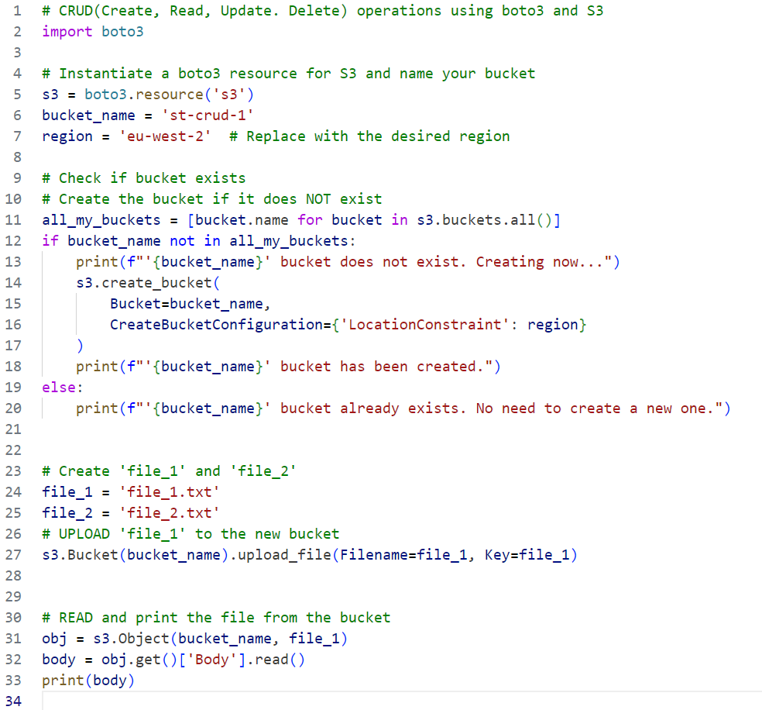

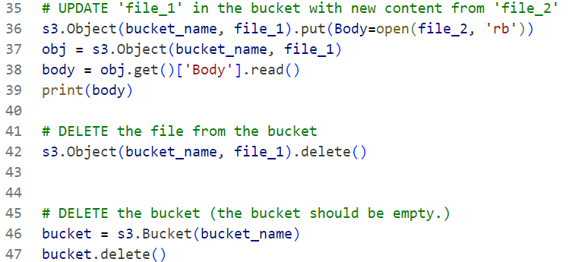

1. **Code Breakdown**

**import boto3:** This line imports the boto3 library, which allows the script to interact with AWS services.

**s3 = boto3.resource('s3'):** This line creates an S3 resource object. This object is a high-level abstraction that allows you to interact with S3 more conveniently.

**bucket_name = 'st-crud-1':** The name of the S3 bucket to be used for CRUD operations.

**region = 'eu-west-2':** The AWS region where the bucket will be created. You can change this to any valid AWS region.

**all_my_buckets = [bucket.name for bucket in s3.buckets.all()]:** This line retrieves all the S3 buckets in the AWS account and stores their names in a list.

**if bucket_name not in all_my_buckets:**: Checks if the desired bucket name already exists.

**s3.create_bucket(...):** If the bucket does not exist, this creates a new S3 bucket in the specified region.

**print(...):** Provides feedback on the creation or existence of the bucket.

**file_1 = 'file_1.txt' and file_2 = 'file_2.txt':** These lines specify the filenames for the files to be used in the S3 operations.

**s3.Bucket(bucket_name).upload_file(...):** This line uploads file_1.txt to the S3 bucket, using the same name as the file’s key in the bucket.

**obj = s3.Object(bucket_name, file_1):** This line creates an object representing file_1.txt in the specified bucket.

**body = obj.get()['Body'].read():** This line reads the content of the file from the S3 bucket.

**print(body):** Prints the content of the file.

**s3.Object(bucket_name, file_1).put(...):** This line updates file_1.txt in the bucket by replacing its content with the content of file_2.txt.

**print(body):** Prints the updated content of file_1.txt after reading it from the bucket.

**s3.Object(bucket_name, file_1).delete():** Deletes file_1.txt from the bucket.

**bucket = s3.Bucket(bucket_name):** Creates a reference to the bucket.

**bucket.delete():** Deletes the S3 bucket. Note that the bucket must be empty before it can be deleted.

1. **Summary**

This script provides a basic framework for performing CRUD operations on files in an Amazon S3 bucket using boto3. It demonstrates how to:

1. **Create a Bucket:** Checks if a specified S3 bucket exists and creates it if it doesn’t.
2. **Upload a File:** Uploads a file to the bucket.
3. **Read a File:** Reads the contents of a file from the bucket.
4. **Update a File:** Updates the contents of the file with another file.
5. **Delete a File:** Deletes the file from the bucket.
6. **Delete the Bucket:** Deletes the bucket after it has been emptied.
7. **Prerequisites**

* **AWS Credentials:** Ensure you have the correct AWS credentials configured with the necessary permissions.
* **File Existence:** Ensure that file_1.txt and file_2.txt exist in the directory where the script is run.

1. **Potential Issues**

* **Credential Errors:** Incorrect or missing credentials can cause authentication issues.
* **Permission Errors:** Insufficient permissions can prevent the bucket from being listed or created.
* **Bucket Name Uniqueness:** Bucket names must be globally unique across all AWS accounts, not just within your account.